

**Write It Down Template**

## Documenting Procedures for Supplier Onboarding and Change Management

Table of Contents

**Vendor Onboarding and Data Management in the Age of Fraud 2**

Fraudsters Love Your Manual Vendor Management Processes 2

Template Project Outline 3

**Part One: New Vendor Onboarding Documentation 4**

Roles and responsibilities 4

**Collecting and vetting vendor information - categories and tools 5**

Required data to onboard 5

**Optional data to onboard 6**

Process for data collection, approval workflows, and tracking 6

**Part Two: Existing Vendor Change Management Documentation 9**

Roles and responsibilities 9

Tools for collecting vendor information changes 9

Data collection, approval workflows, and tracking 9

**Part Three: Audit Process Documentation 10**

**Your Process Template 11**

**Part One: New Vendor Onboarding Documentation 12**

Roles and responsibilities 12

Tools for collecting vendor information 12

Required data to onboard 12

Optional data to onboard 13

Process for data collection, approval workflows, and tracking 13

**Part Two: Existing Vendor Change Management Documentation 14**

Required data to change existing record 14

Optional data to onboard 14

Process for data collection, approval workflows, and tracking 14

**Part Three: Audit Process Documentation 15**

**Closing Message From Us 15**

Want Personalized Help From PaymentWorks? 15

Want More Resources? 15

## Vendor Onboarding and Data Management in the Age of Fraud

### Fraudsters **Love** Your Manual Vendor Management Processes

With spoofing, vendor email compromise, executive identity impersonation, and whatever they think of next, it may feel as if you are fighting a defensive war on too many fronts.

And it’s true. You cannot let your guard down even for a moment. Fraudsters are patient and will eventually exploit any weakness in your process they can find.

With this as a backdrop, it might seem you’ll never get a good night's sleep again.

But you can!

How? **Because the root of all of these losses is easy to identify: vendor additions and changes.**

Effective vendor onboarding and management practices are crucial for businesses to mitigate risks and protect their operations. Effective and **documented** vendor onboarding and management practices are a **requirement** if a business expects to have any level of insurance protection in place as a backstop.

If your vendor onboarding or updating process involves any manual collection, verification, or inputs, fighting fraud is extremely difficult. And getting insurance coverage is likely impossible.

PaymentWorks understands that the manual aspect of vendor management is exactly what makes it so risky. Most organizations - even today - rely upon institutional knowledge handed from one person to another to get this important business function done. Almost no organizations we speak with have documented their vendor onboarding and change management procedures.

These practices are comically out of date for today's fraud landscape. And if they are documented, they are either rooted in assumptions which are no longer valid, or not actually followed in practice.

Remember: insurance covers processes, not people.

This template is a starting point. Use it to gather the right functions in the room to have a conversation about your organization's vendor management processes today.

Specifically, this template will help guide productive conversations with your own team, other departments, and leadership about:

* The efficiency, security, and value of your current vendor management processes.
* What you believe needs to improve in your processes.
* How to document and follow your processes.

### Template Project Outline

**Ready to roll up your sleeves? You’ll need to invite the right people to the table.**

**Team Players**: Risk, vendor management, AP, procurement, treasury

**Goals/Outcomes:** 1) Reduce the risk of financial losses due to fraud associated with vendor and vendor change management and 2) Establish an audit trail for insurance in the aftermath of a fraud instance

**The fine print:**

*No document can completely address the details of each individual company. This is a broad framework for review, iteration and implementation. We offer this as a suggestion to create your own documentation process.*

*This template presumes a documented list of vendors in a financial database.*

**Let’s Get Started!**



## 

## Part One: New Vendor Onboarding Documentation

### Roles and responsibilities

First you will define and establish the roles and responsibilities for positions responsible for collection, verification, and inputting of vendor data into your financial system. Segregation of duties is imperative to prevent opportunities for insider-assisted vendor fraud.

Steps to include:

* Definitions for each role that touches vendor onboarding.
* Clearly documented responsibilities for each role.
* Named employees currently serving in each role, with back ups delineated.

**Best Practices:**

* Ensure no one person can control the entire process from beginning to end.
* Have more than one person assigned to each role as back up.
* Each role should have different back ups to keep segregation of duties.
* Authority to buy and authority to work with a vendor should adhere to the segregation of duties process.
* Date and sign each iteration of the list for audit purposes.

**Sample Matrix - Roles and Responsibilities**

|  |  |  |
| --- | --- | --- |
| ROLE | RESPONSIBILITY | ASSIGNED TO <*last updated 08/12/23, by Tisha Belknap, AP Directo*r> |
| *Vendor Desk Analyst* | *Verification of all required fields. Inputting verified information into the financial system.* | *Heather Van Vliet, Vendor Desk Manager*  *Back up: Carlos Garcia, Vendor Desk Manager* |
| *Buyer* | *Sending requirements to vendor, directing submission of required data to vendor desk analyst.* | *James Greene, Buyer II*  *Melanie Mabuis, Buyer III*  *Back up: Julia Rose, Buyer*  *Back up: Patricia Wu, Buyer* |
| *Compliance* | *Verification and documentation of sanctions list checks.*  *Collection and vetting of conflicts of interest attestations.* | *Theo Greenburg, Director of Corporate Compliance*  *Back up: Shazdhe Iqbal, Global Head of Compliance* |

### Collecting and vetting vendor information - categories and tools

List the internal and 3rd party tools your team uses as part of the vendor onboarding and change management process.

**Best Practices:**

* Verify the following data with 3rd party vendors:
  + Tax ID.
  + Physical and remit address.
  + Bank ownership.
  + Sanctions status.

**Sample Matrix - Categories and Tools**

| **Category** | **Tool** | **Deliverable** | **Business Owner** |
| --- | --- | --- | --- |
| *In-house Vendor Form* | *Adobe pdf, email* | *Completed pdf with all relevant fields submitted correctly* | *Person doing business directly with the vendor* |
| *Banking Verifications* | *Early Warning System* | *Bank account ownership verification* | *Vendor Desk Analyst/AP* |
| *Tax ID confirmation* | *IRS TinCheck* | *Verifying tax ID numbers* | *Vendor Desk Analyst/AP* |
| *Sanctions monitoring* | *Visual Compliance* | *Check relevant sanctions lists* | *Compliance Manager* |

### Required data to onboard

List the minimum data required to input vendor information into your financial system, paying close attention to what is required by vendor type, e.g., a business entity vs an individual; foreign vs. domestic.

**Sample Matrix - Required Data**

|  |  |
| --- | --- |
| Input Type | Vendor Type |
| *Company Name* | *EIN* |
| *Legal First and Last Name* | *SSN, some EIN* |
| *Tax Classification* | *ALL* |
| *W9* | *All* |
| *Payment Type* | *All* |

### Optional data to onboard

Outline optional vendor data, and what specifically will trigger collection of this data.

**Sample Matrix - Optional Data**

|  |  |
| --- | --- |
| Data | Trigger |
| *Sanctions list status (e.g., OFAC or debarment)* | *Using federal research dollars to pay for this vendor* |
| *Conflict of Interest attestations* | *Any contractor with ties to the organization* |
| *Diversity Certifications for Historically Underutilized Businesses* | *Internal policies* |
| *Certificates of insurance* | *Internal policies* |

### Process for data collection, approval workflows, and tracking

**Best Practices**:

* A flowchart with if/then scenarios created from the steps will be easiest to follow
* Zero trust in documents and email. Process *must* include vetting on submitted data.
* A paper/pdf “vendor form” must also have zero trust.
  + Corroborate requests with internal contact who works with the vendor.
  + Confirm with a known entity at the vendor BEFORE you send a vendor form.

**Sample Matrix - Process Steps**

|  |  |  |
| --- | --- | --- |
| Onboarding Process Step | Department Responsible | Position Responsible |
| *Confirm veracity of the request with internal business owner* | *Accounts Payable or Procurement* | *Buyer or Vendor Desk Analyst* |
| *Send New Vendor link to pdf* | *Procurement* | *Person doing direct business with vendor* |
| *Submit filled pdf to vendor desk* | *Department doing direct business with vendor* | *Person doing direct business with vendor* |
| *Review pdf and determine validity of submitted responses using:*  *TinCheck, Early Warning System, Smarty Streets* | *Accounts Payable* | *Vendor Desk Analyst* |
| *Check Sam.gov and OFAC lists for sanctions violations* | *Compliance* | *Sponsored funds manager* |

This section will likely take the most effort to document, as you add details on if/then scenarios.

**Sample If/Then Process Flowchart for Accepting Vendor Documents:**

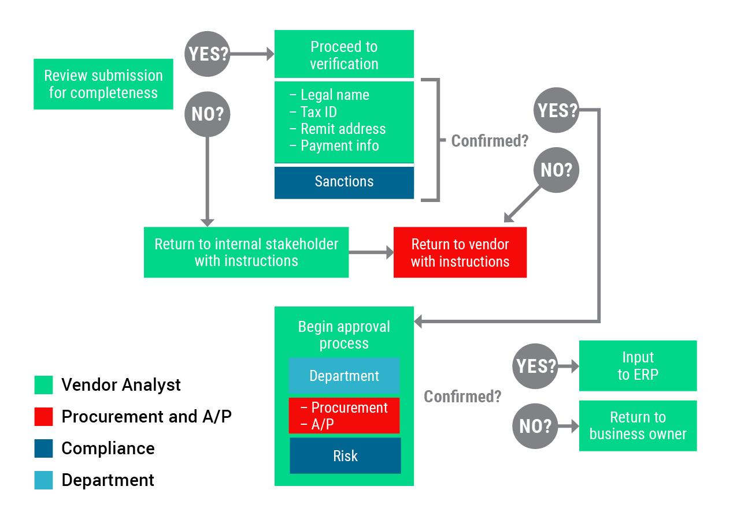

**Sample If/Then Process FlowChart for Verification Phone Calls to Vendors**:

*If vendor banking does not pass Early Warning System, the bank account information must be manually verified using the following process steps:*

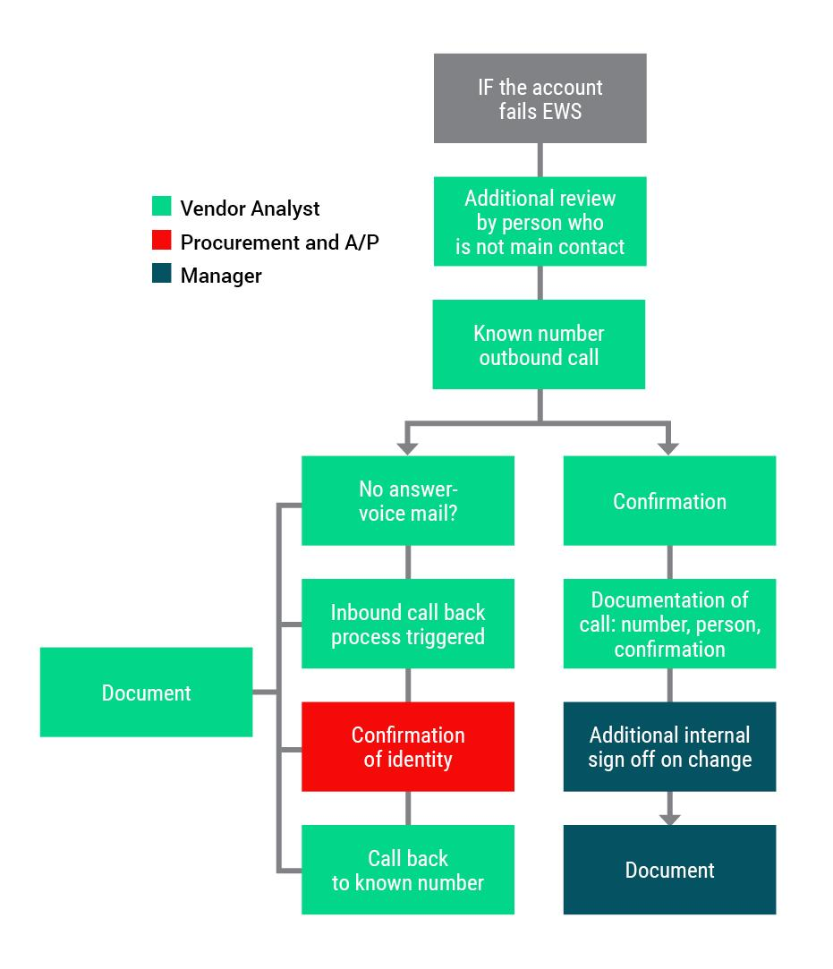

## Part Two: Existing Vendor Change Management Documentation

If there are variances in your process for accepting changes from existing vendors, you’ll need to repeat the process in Part One. Specifically, you’ll need to document and define:

### Roles and responsibilities

Document if different from onboarding roles and responsibilities.

### Tools for collecting vendor information changes

Document if different from onboarding tools.

### Data collection, approval workflows, and tracking

Document if different from onboarding process.

## Part Three: Audit Process Documentation

The process itself is meaningless if it isn’t followed. Regular audits that identify bottlenecks, fraud vectors, and errors will ensure compliance and keep all parties invested in the outcomes.

Steps:

* Define ownership for documentation and enforcement of the process.
* Define time frames for auditing existing roles, tools, and workflows.
* Define reporting, tracking, and ownership for auditing.

**Sample Matrix - Governance**

|  |  |  |  |
| --- | --- | --- | --- |
| Process Item | Business Owner | Audit Owner | Timing |
| *New Vendor required data* | *Vendor Desk Analyst* | *Director, Risk* | *Biannual review and sign off* |
| *Bank verification tools and process review* | *Vendor Desk Analyst* | *Director, Finance* | *Annual SOW review* |
| *New Vendor process adherence* | *Buyer, Vendor Desk Analyst* | *Director, Finance* | *Quarterly Audits* |

**Notes**:

* *Compliance and Controllers Offices shall co-author documentation of process and round robin review ownership on a quarterly basis.*
* *Each quarter the offices, along with Vendor Management personnel, will review existing tools and workflows to identify gaps and amend processes.*
* *VP, Compliance and CFO shall sign off on final audits each quarter.*

## Your Process Template

Now it’s your turn.

Use this template to audit your own vendor management processes with your team and other departments. Afterwards, you’ll be able to have a productive conversation about what’s working, what’s putting you at risk, any missed revenue opportunities, and tangible ways you can make your vendor management more efficient, secure, and profitable.

## Part One: New Vendor Onboarding Documentation

### Roles and responsibilities

Define and establish the roles and responsibilities for positions responsible for collection, verification, and inputting of vendor master data into your financial system.

|  |  |  |
| --- | --- | --- |
| **Role** | **Responsibility** | **Assigned to** <*last updated, name*> |
|  |  |  |
|  |  |  |
|  |  |  |
|  |  |  |
|  |  |  |

### Tools for collecting vendor information

Inventory all tools and platforms used to collect and verify vendor data.

|  |  |  |
| --- | --- | --- |
| **Tool** | **Deliverable** | **Business Owner** |
|  |  |  |
|  |  |  |
|  |  |  |
|  |  |  |
|  |  |  |

### Required data to onboard

Document all data required to onboard a new vendor.

|  |  |
| --- | --- |
| **Field Name** | **Vendor Type *e.g.,*** *EIN, SSN, ALL* |
|  |  |
|  |  |
|  |  |
|  |  |

### Optional data to onboard

Outline optional data, and what triggers collection of the data.

|  |  |
| --- | --- |
| **Data** | **Trigger** |
|  |  |
|  |  |
|  |  |
|  |  |

### Process for data collection, approval workflows, and tracking

|  |  |  |
| --- | --- | --- |
| **Onboarding Process Steps** | **Department Responsible** | **Position Responsible** |
|  |  |  |
|  |  |  |
|  |  |  |
|  |  |  |
|  |  |  |

## Part Two: Existing Vendor Change Management Documentation

### Required data to change existing record

Document all data required to change an existing vendor record in the ERP.

|  |  |
| --- | --- |
| **Field Name** | **Vendor Type *e.g.,*** *EIN, SSN, ALL* |
|  |  |
|  |  |
|  |  |
|  |  |

### Optional data to onboard

Outline optional data, and what triggers collection of the data.

|  |  |
| --- | --- |
| **Data** | **Trigger** |
|  |  |
|  |  |
|  |  |
|  |  |

### Process for data collection, approval workflows, and tracking

|  |  |  |
| --- | --- | --- |
| **Onboarding Process Steps** | **Department Responsible** | **Position Responsible** |
|  |  |  |
|  |  |  |
|  |  |  |
|  |  |  |
|  |  |  |

## Part Three: Audit Process Documentation

|  |  |  |  |
| --- | --- | --- | --- |
| **Process Item** | **Business Owner** | **Audit Owner** | **Timing** |
|  |  |  |  |
|  |  |  |  |
|  |  |  |  |
|  |  |  |  |

## Closing Message From Us

It can feel near-impossible to establish a vendor management strategy that protects against fraudsters, makes the jobs of your vendor desk staff easier, and generates profit for your organization.

But with the right resources and processes in place–a secure, efficient, and profitable vendor management strategy CAN be your reality.

That’s why we created the Write It Down Template–to help you start productive conversations and decisions about your organization’s vendor management strategy…and move one step closer to your ideal state in payables.

### Want Personalized Help From PaymentWorks?

[Schedule some time to speak with our team](https://www.paymentworks.com/contact/)

### Want More Resources?

Explore our recent blogs–they’re full of knowledge and tangible tips:

[Tackling Accounts Payable Challenges: Effective Solutions](https://www.paymentworks.com/2023/05/17/accounts-payable-challenges/)

[B2B Payments Fraud Fraud in Times of Chaos](https://www.paymentworks.com/2023/03/30/business-payments-fraud-in-times-of-chaos-2023-edition/)

[Case Study with Cabarrus County and Their $2.5M Problem with a Fraudster](https://www.paymentworks.com/resources/cabarrus-county-immediate-and-long-term-risk-mitigation-after-a-2-5m-scam/)

[Social Engineering Fraud Never Sleeps: 3 Ways to Prevent It](https://www.paymentworks.com/2022/09/07/social-engineering-fraud-never-sleeps/)

[Vendor Management Tips From the Experts Themselves](https://www.paymentworks.com/2023/04/26/vendor-management-tips-from-experts/)

